1. **Problem Name:** Print 1-100 numbers using loop.

**Problem Code & Output:**

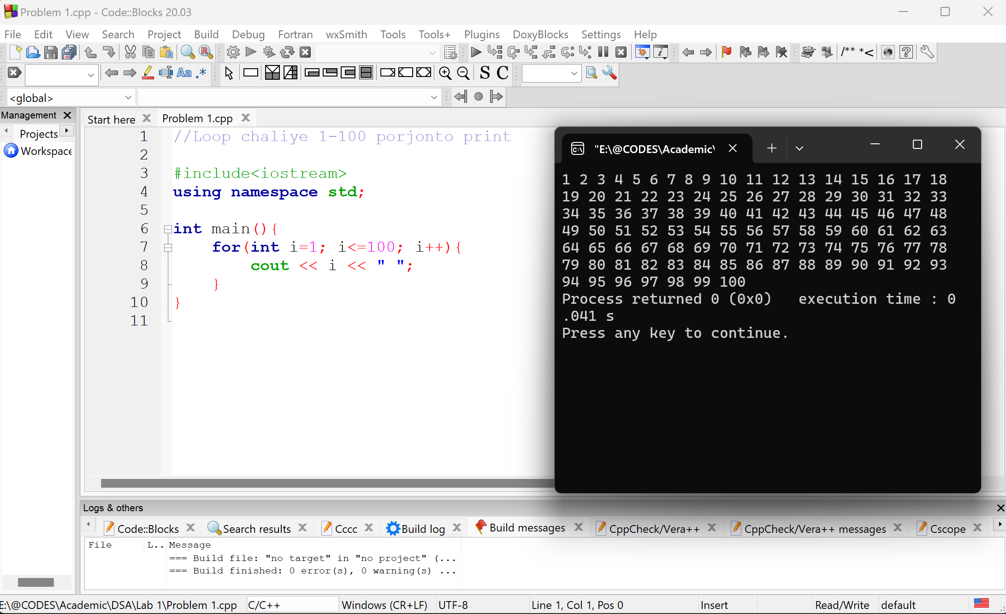

1. **Problem Name:** A program to input an array of user-defined size and display its elements.

**Problem Code & Output:**

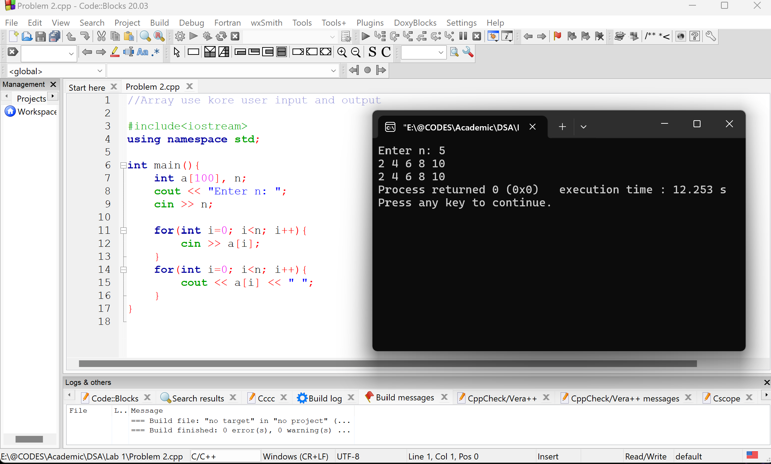

1. **Problem Name:** A program to input an array of user-defined size, calculate the sum of its elements, and display the result.

**Problem Code & Output:**

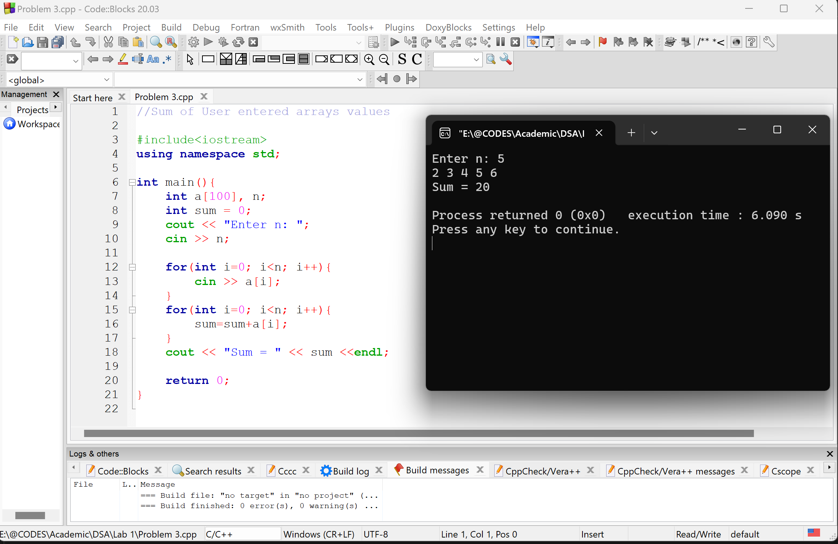

1. **Problem Name:** A program to input an array of user-defined size, find the maximum and minimum elements, and display them.

**Problem Code & Output:**

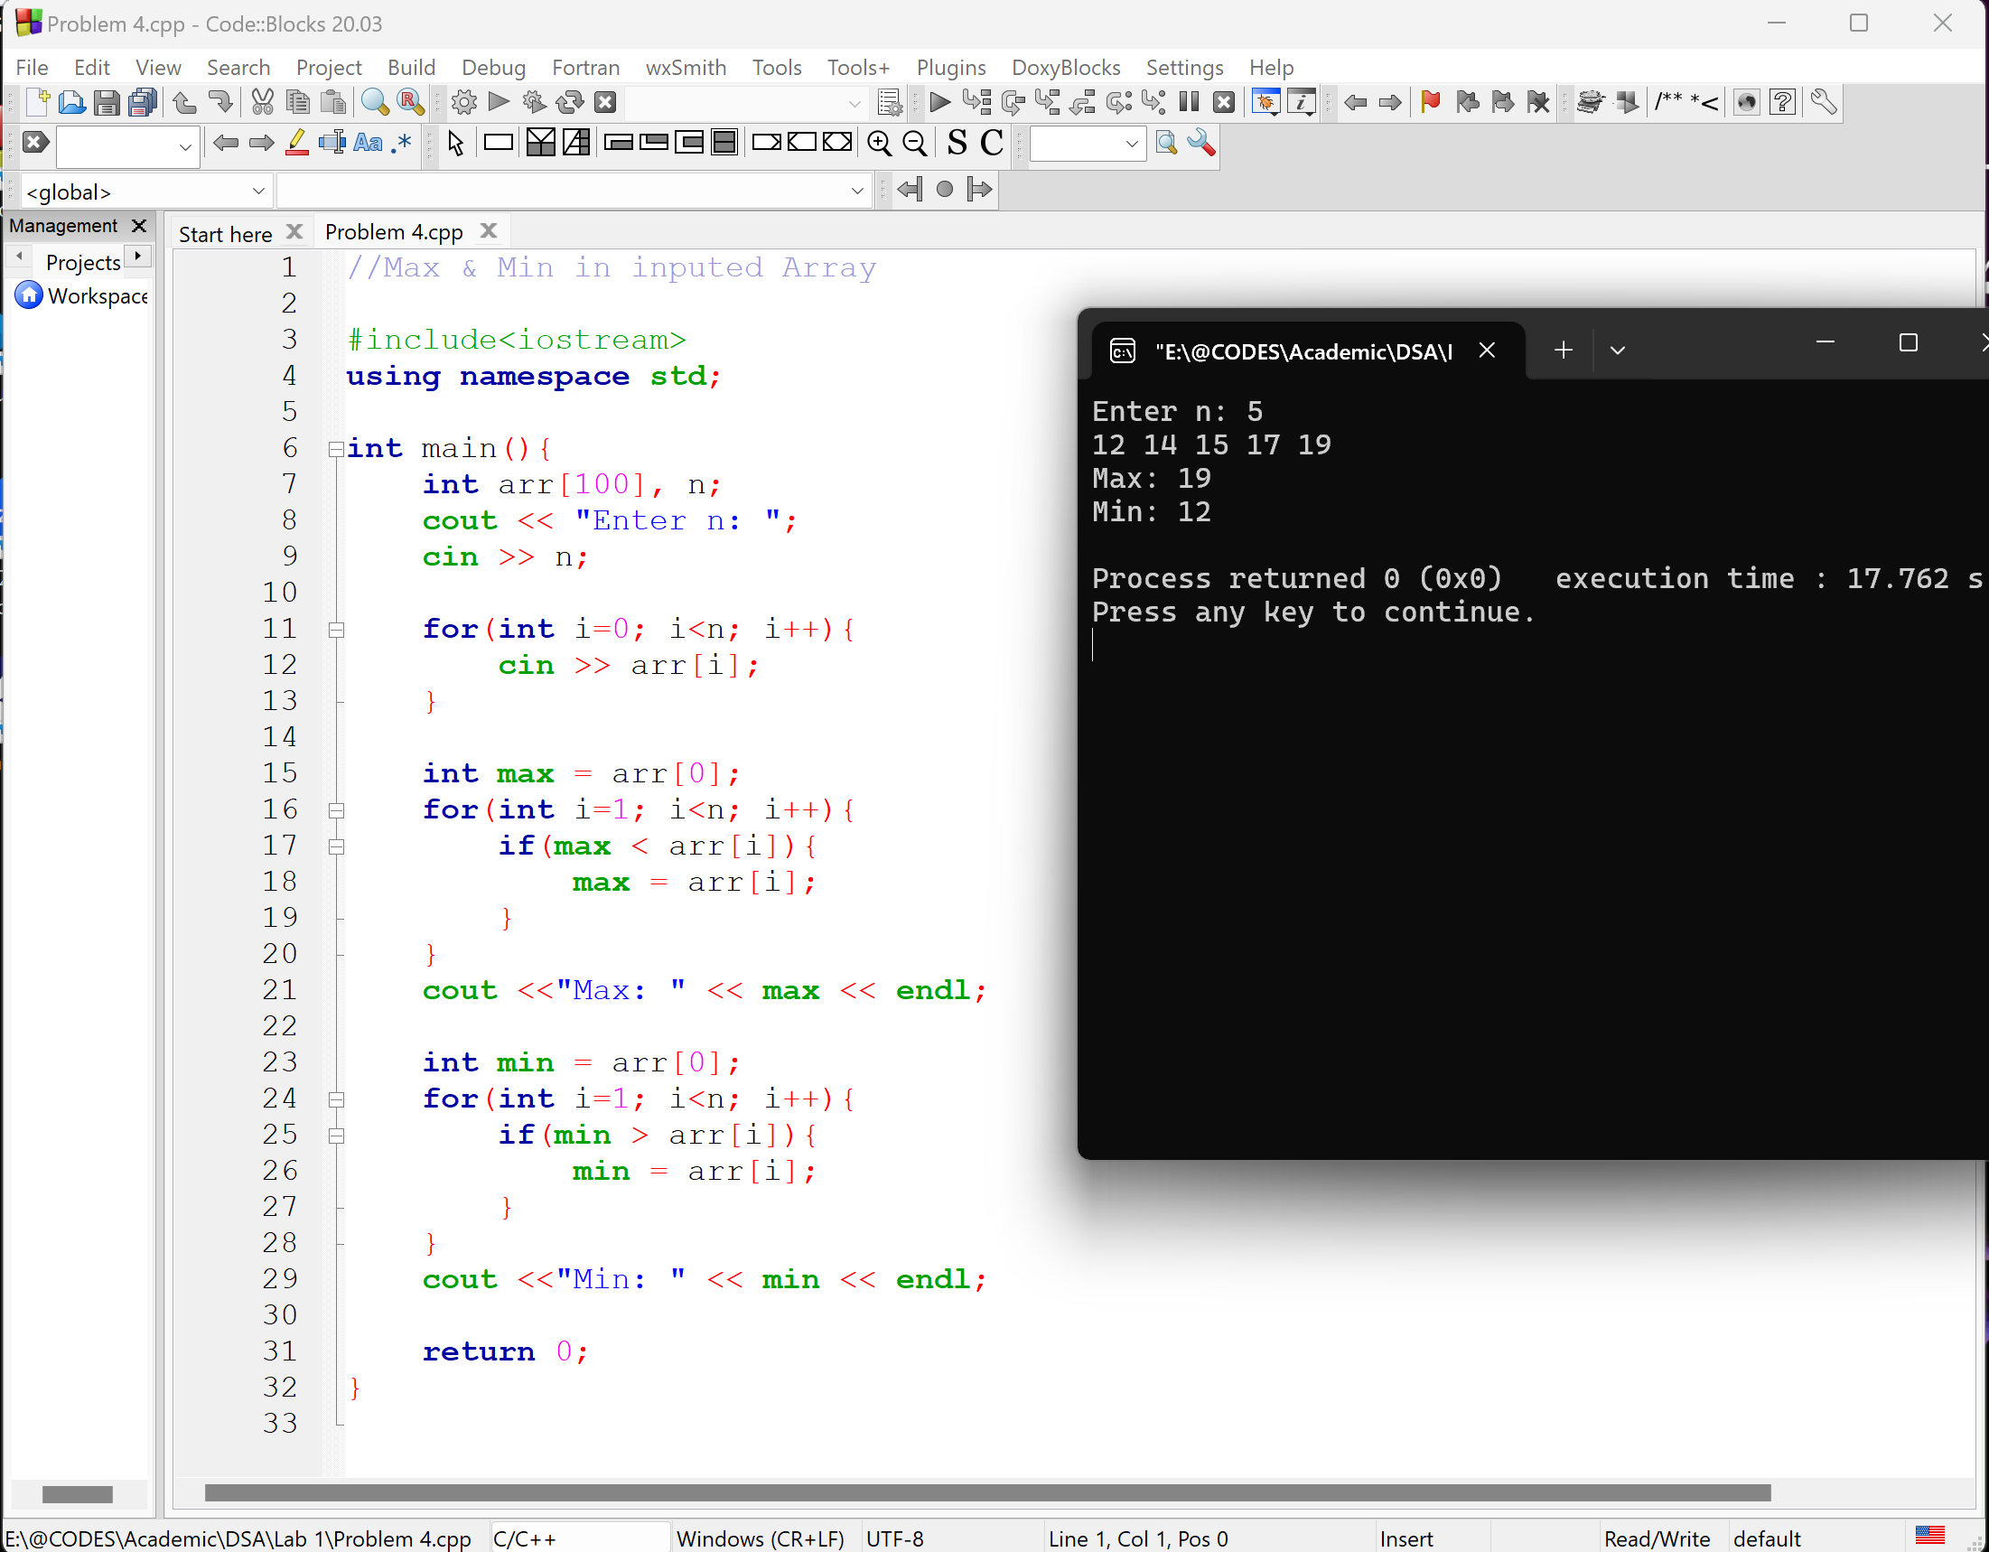

1. **Problem Name:** A program to input an array of user-defined size, separate the even and odd elements, and display them accordingly.

**Problem Code & Output:**

